Student Name a Date a
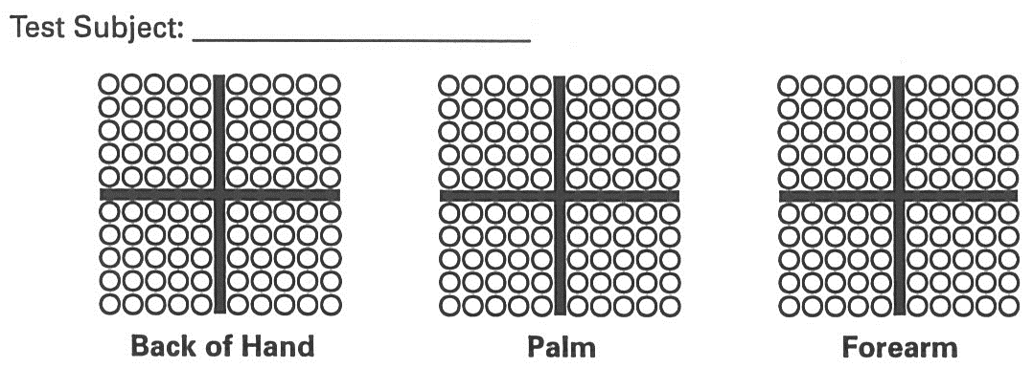
Answer Sheet
Cold Thermoreceptor Distribution

Location | Back of Hand | Palm | Forearm
# of Cold Spots
Density
(receptors/mm²)

Warm Thermoreceptor Distribution

Location | Back of Hand | Palm | Forearm
# of Warm Spots
Density
(receptors/mm²)

Application Questions

A

A
- a

